**JAVA SYSTEM SETUP**

**JDK 17 Download and Installation Steps**

**Download Process**

**Step 1 –** To download jdk 17 go to the below mentioned link <https://www.oracle.com/java/technologies/javase/jdk17-archive-downloads.html>

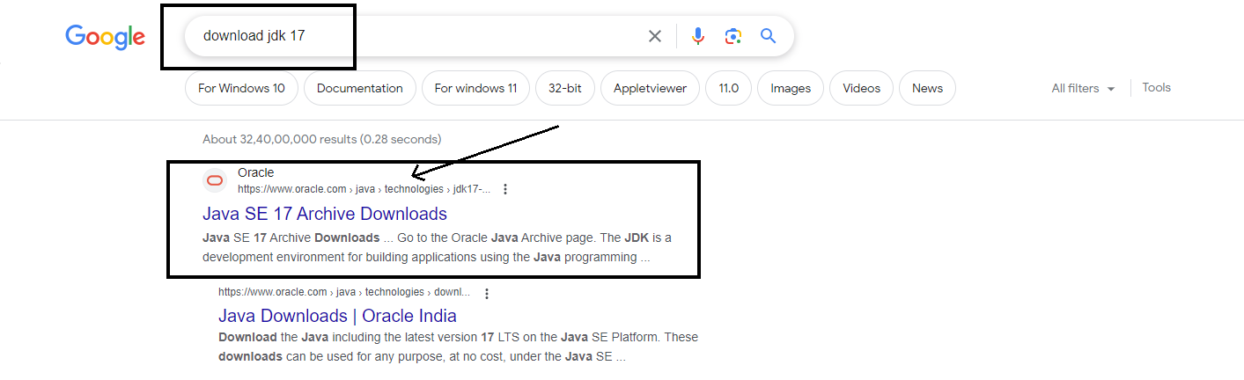

**Step 2 –** Click on the Windows x64 Installer or visit this link : <https://download.oracle.com/java/17/archive/jdk-17.0.8_windows-x64_bin.exe> and the download will start automatically.

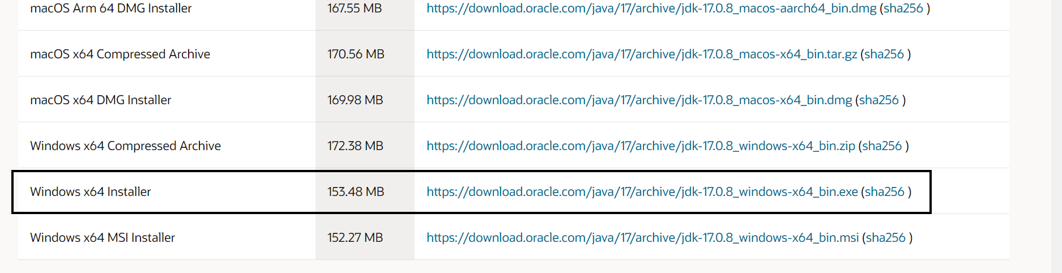

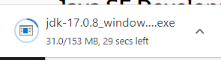

After Downloading JDK 17 installation process will start

**Installation Process**

**Step 1 –** Click on next

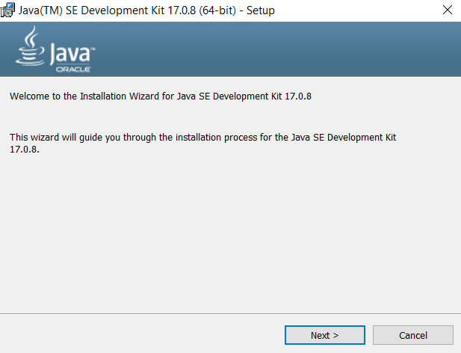

**Step 2 –** Click on next after specifying the location where jdk17 will be installed. 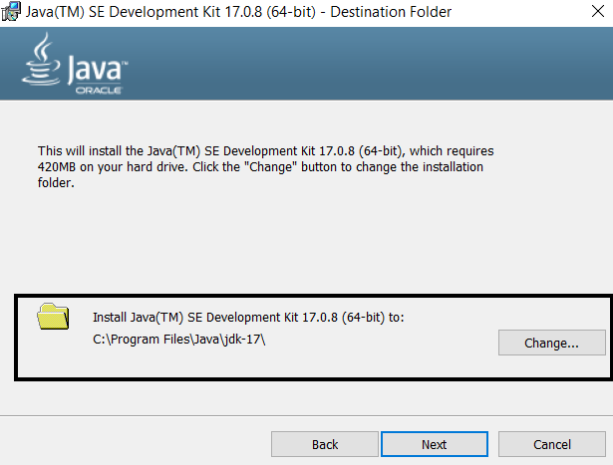

**Step 3 –** After this click the close button to finish the installation process.

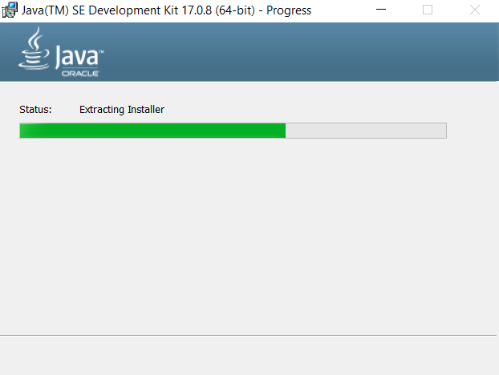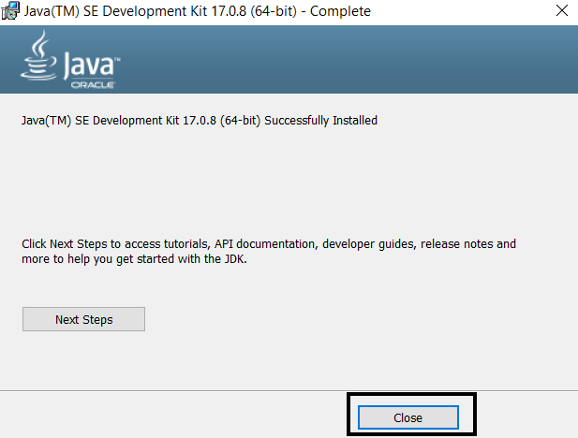

**Step 4 -** Checking whether the java is installed or not

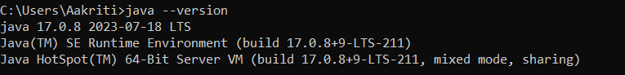

**Setting Up the Environment Variables**

**Step 1 –** Search for “Environment Variables” in the search bar and click on Edit the system Environment Variable.

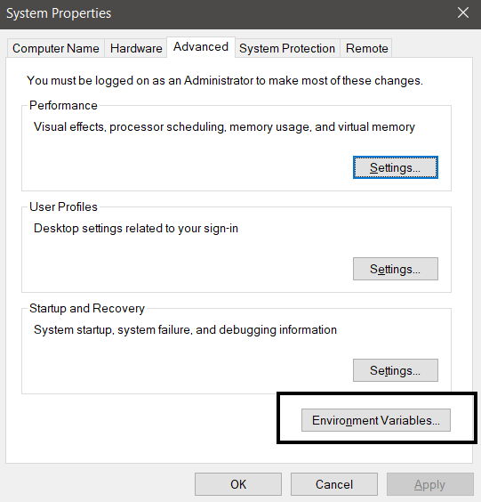

**Step 2 –** Go to the File Explorer copy the path where jdk17 was installed .

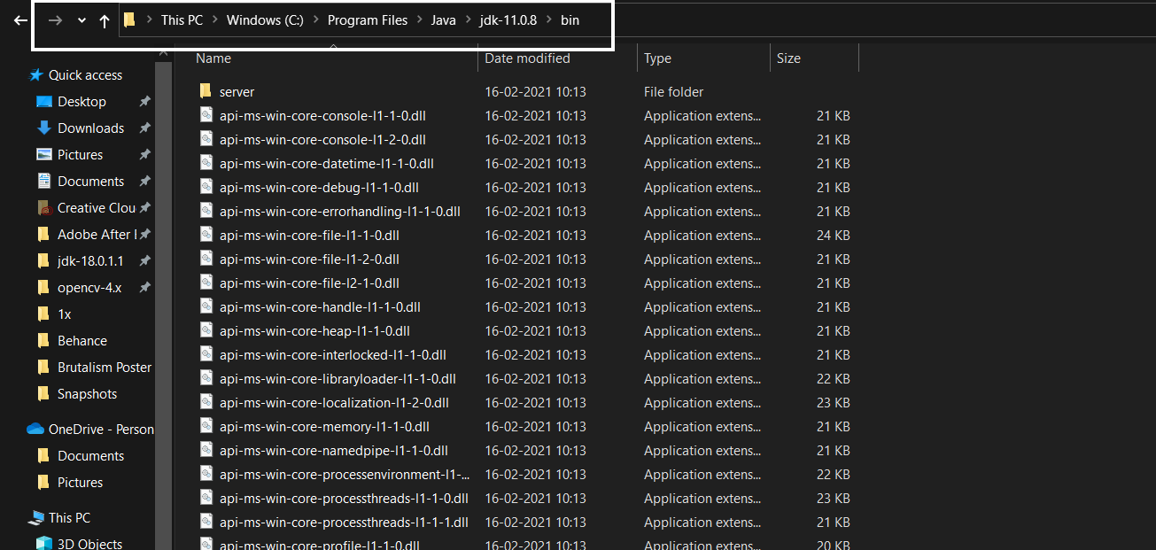

**Step 3 –** In ‘System Variables’ , select ‘Path’ and click on the Edit button.

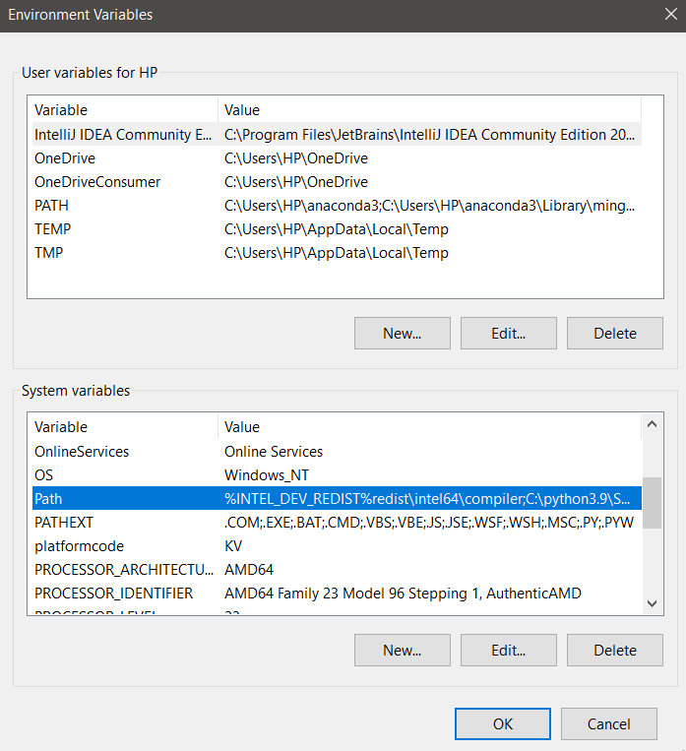

**Step 3 –**  click on ‘New’, paste add the copied path and then select Ok .

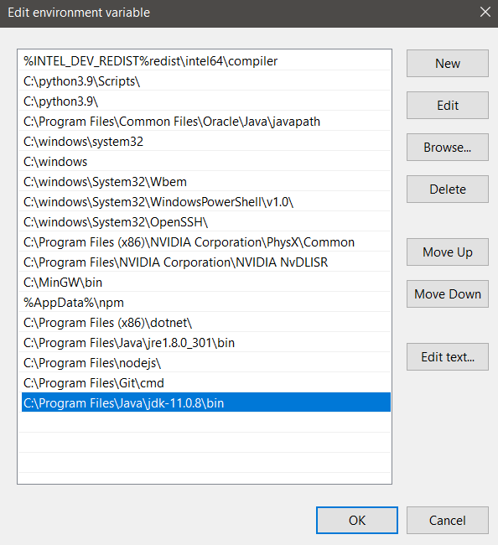

**GITBASH Download and Installation Steps**

**Download Process**

**Step 1 –** To download gitbash click on the link : <https://git-scm.com/download/win>

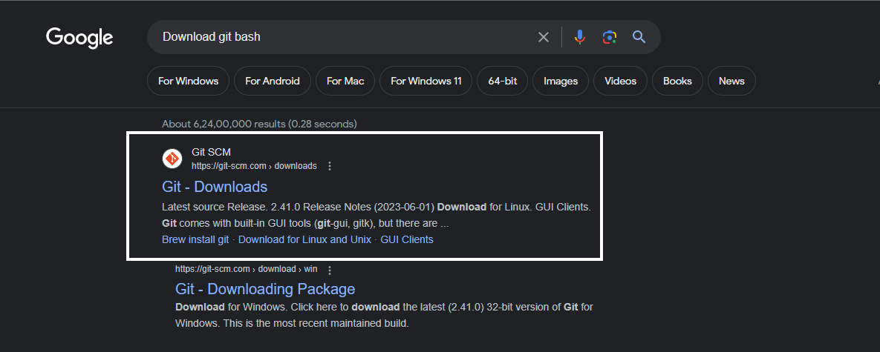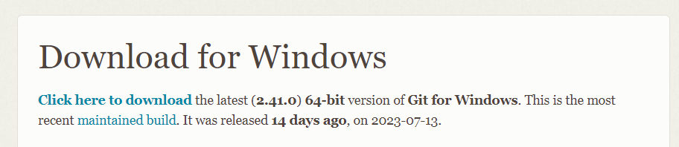

**Step 2 –** Click the link “click here to download” and download will start

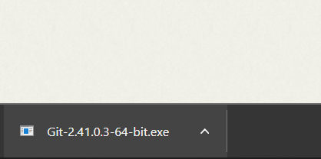

**Installation Process**

**Step 1 –** Click on next

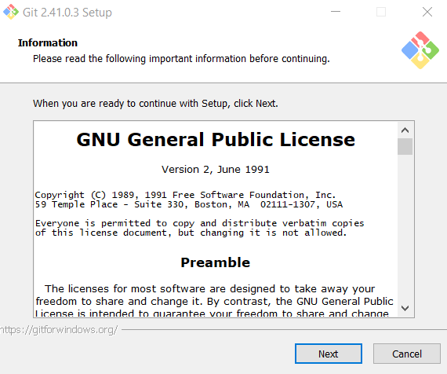

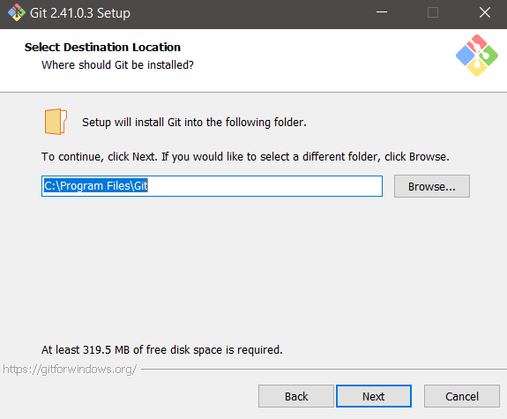

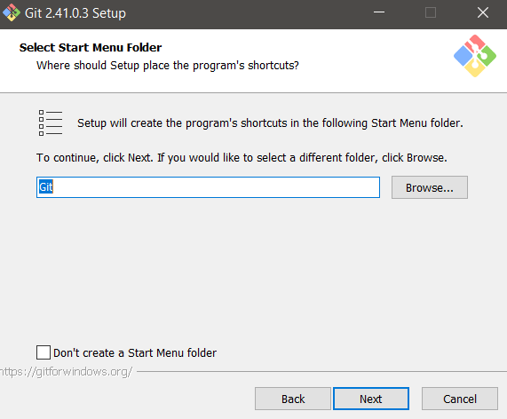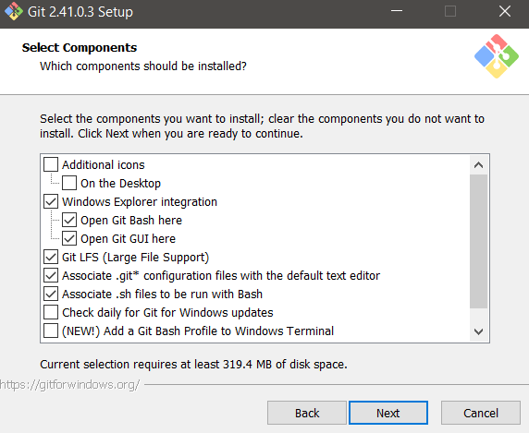

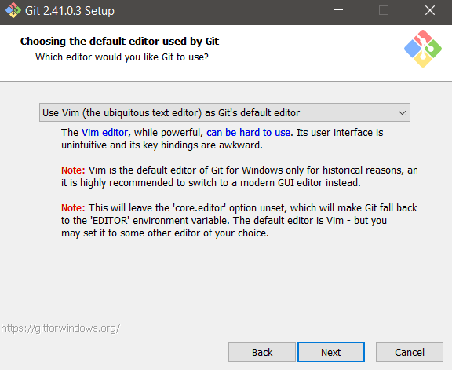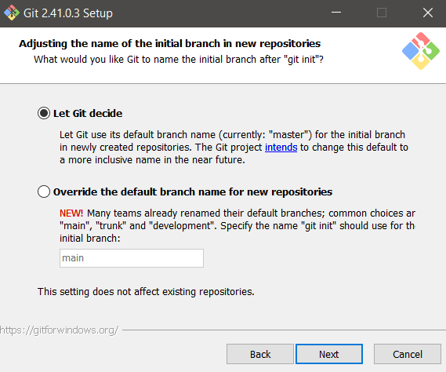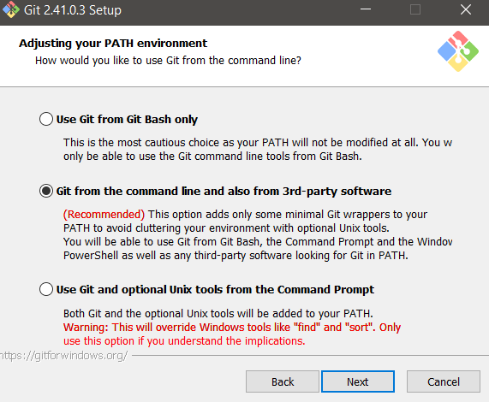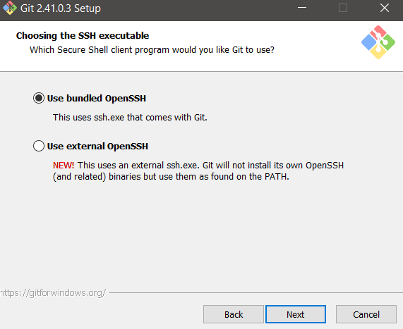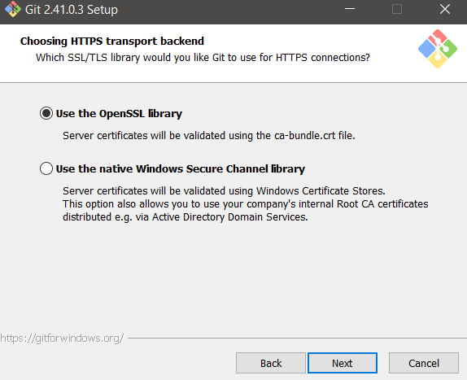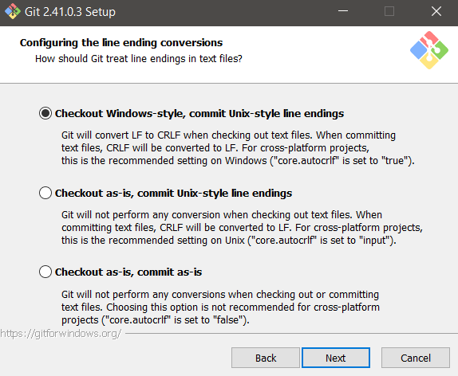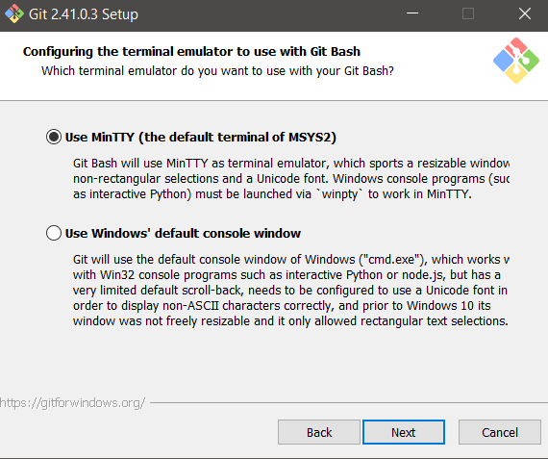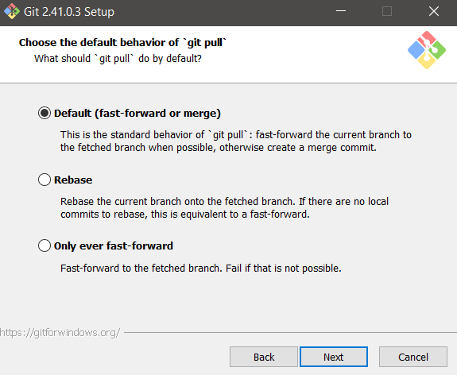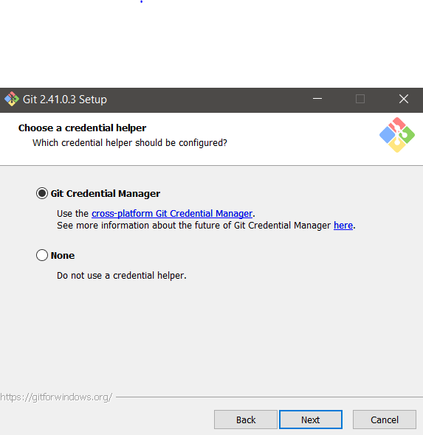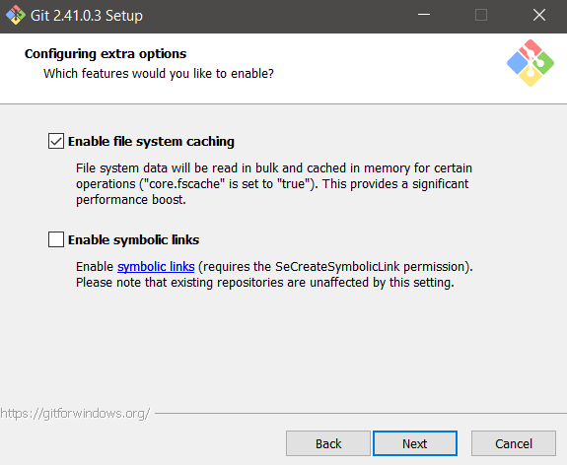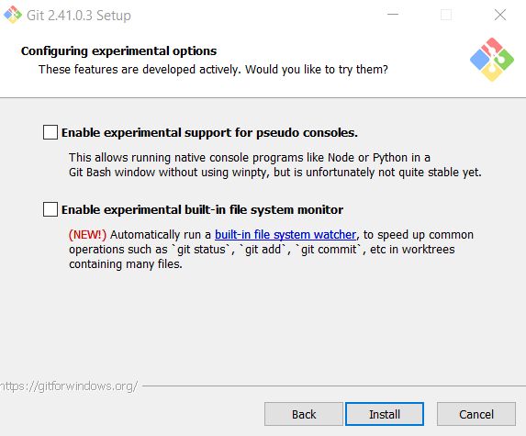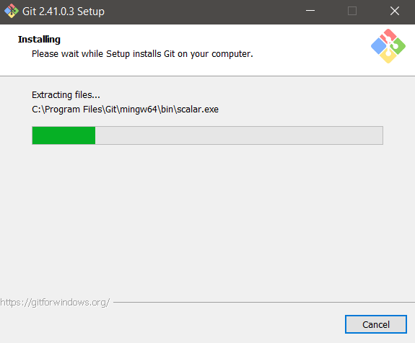

**Step 2 –** Click on Finish to complete the installation.

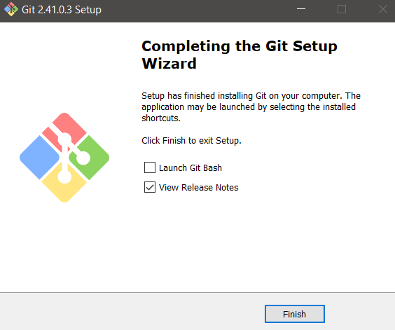

**Setting Up the Environment Variables**

**Step 1 –** Copy the path where gitbash is installed.

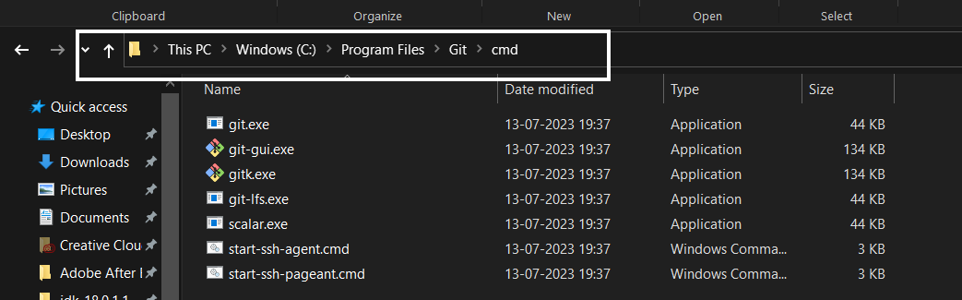

**Step 2 –** Search for Environment Variables in search bar and open”Edit system environment variables”.



**Step 3 –** Now go to ‘System Variables’ and then select ‘Path’ and click on ‘Edit’.



**Step 4 -**  click on ‘New’ and add the copied path and then select Ok.

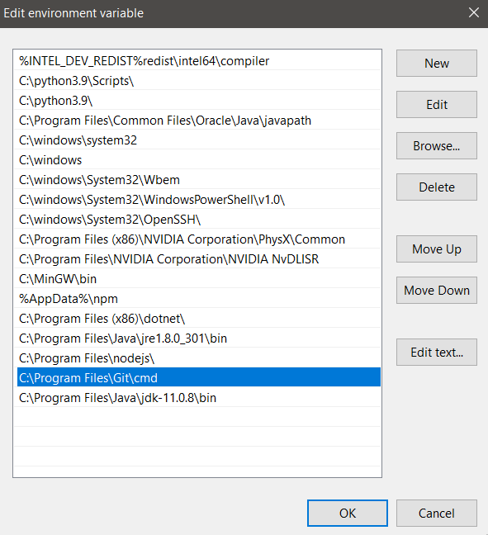

**Step 4 –** To check the version of git installed the following command can be used.

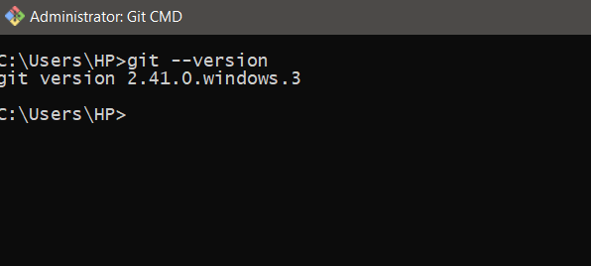

**GIT COMMANDS**

1. **How to create New Branch and see the original branch**

We can create New Branch with command :

**‘git branch -c new_branch_name’**

We can check the current branch with command :

**‘git branch’**

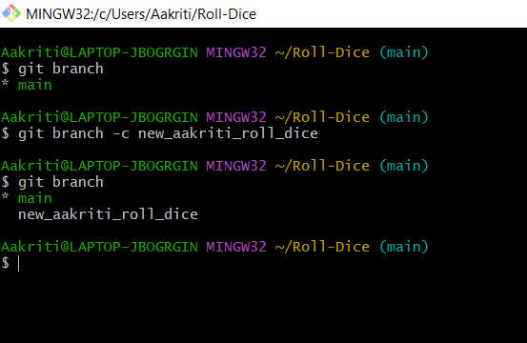

1. **How to push to the new_branch or the existing branch**

**Command :**

Git push origin new_branch_name

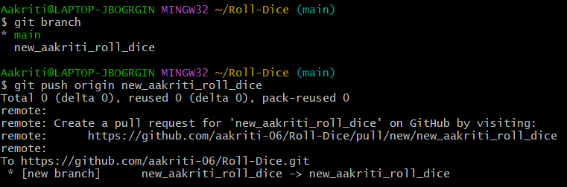

1. **How to change the existing branch to a new branch**

**Command :**

Git checkout new_branch_name

checkout.PNG

1. **How to add and commit the changes in gitbash**

**Command :**

git add file_name

git commit –m “message”

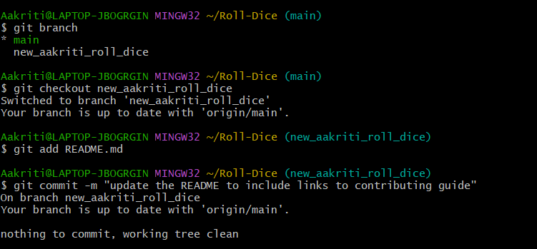

1. **How to pull from the repository on github**

**Command :** git pull

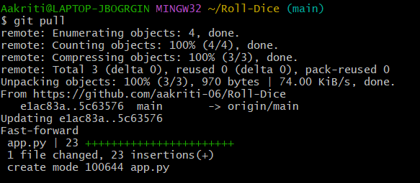

**IDE(Intellij-2023) Download and Installation Steps**

**Download Process**

**Step 1 –** Search for “Download Intellij idea 2023” or otherwise click on the below link

https://www.jetbrains.com/idea/download/?section=windows

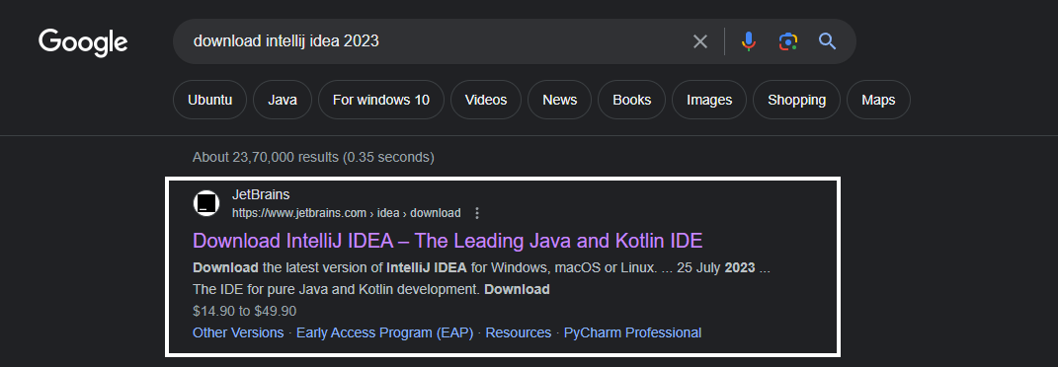

**Step 2 –** Click the Download button and Download will start

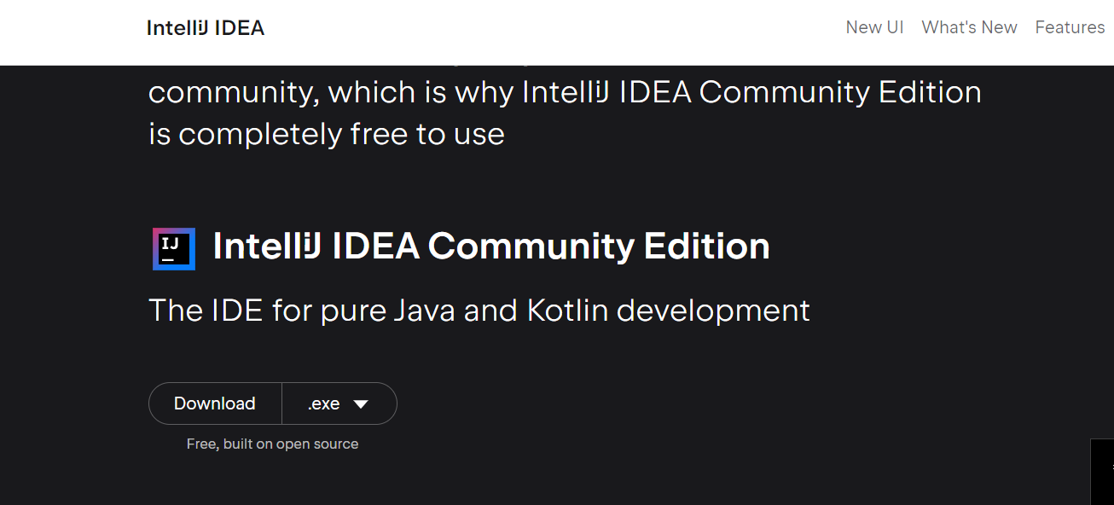

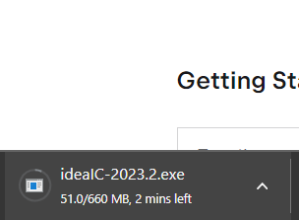

**Installation Process**

**Step 1 –** Click on next

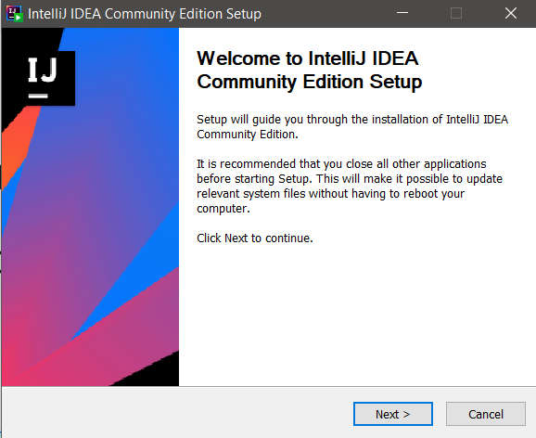

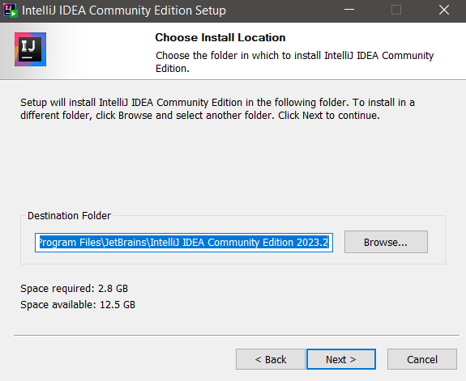

**Step 2 –** Checkmark the options as shown in the screenshot below.

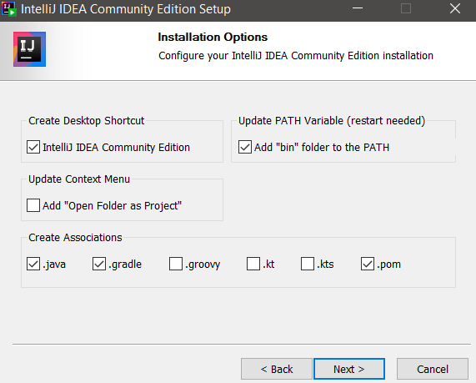

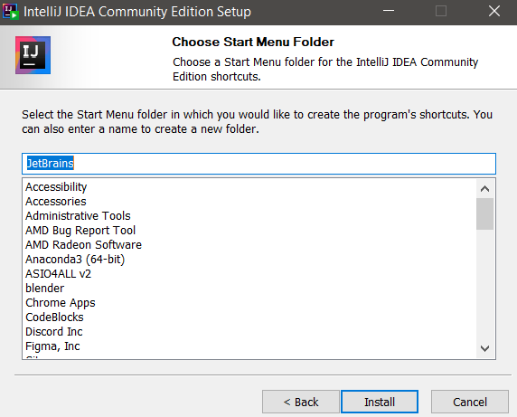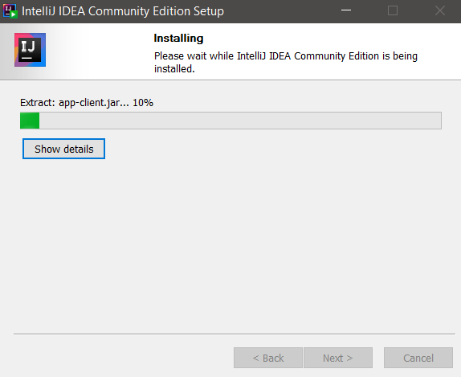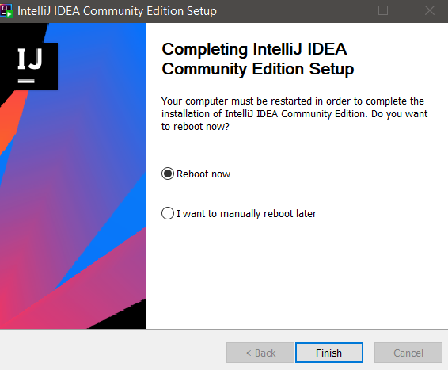

**Step 3 –** Click on Finish

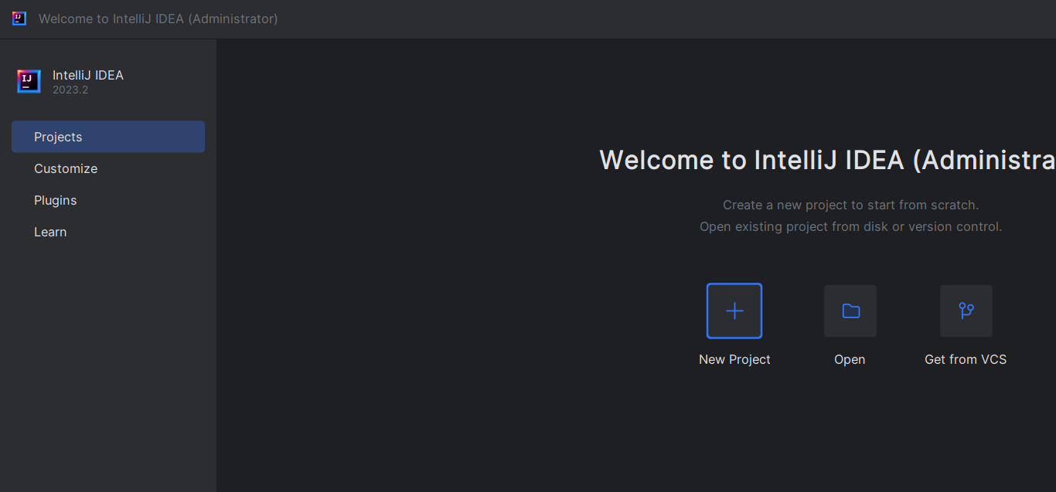

**Set Environment Variable**

**Step 1 –** Copy the path where intelliJ is installed and open environment variables.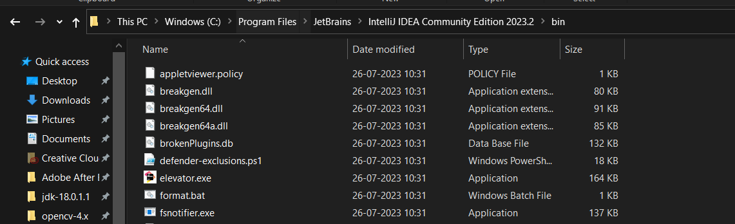

**Step 2 –** Add environment variables and click on User variable and go to “Path” and then click Edit. Add the copied path if not present there.

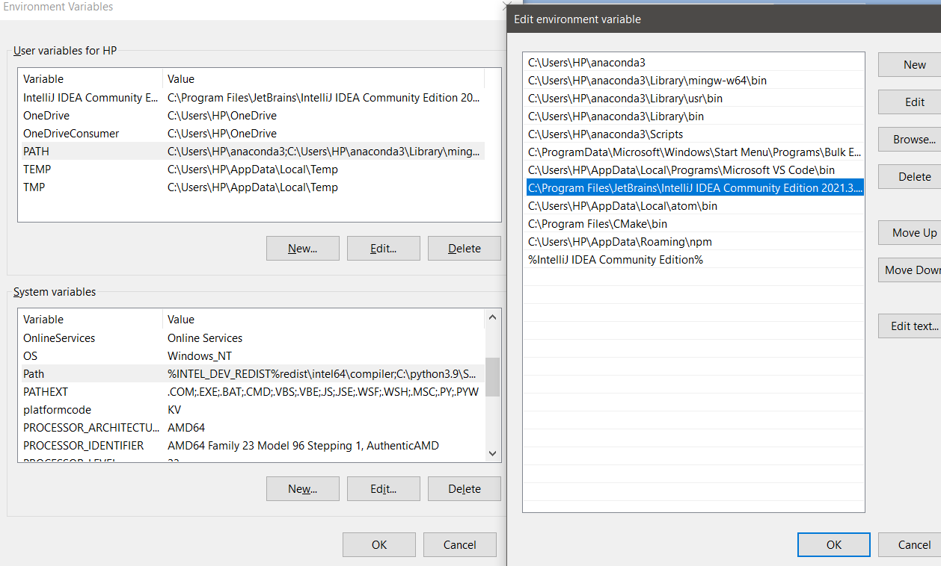

**Maven Download and Installation Steps**

**Setting Up Environment Variable and Download Process**

**Step 1 –** To download maven search for maven on google and click on the link as shown in the image.

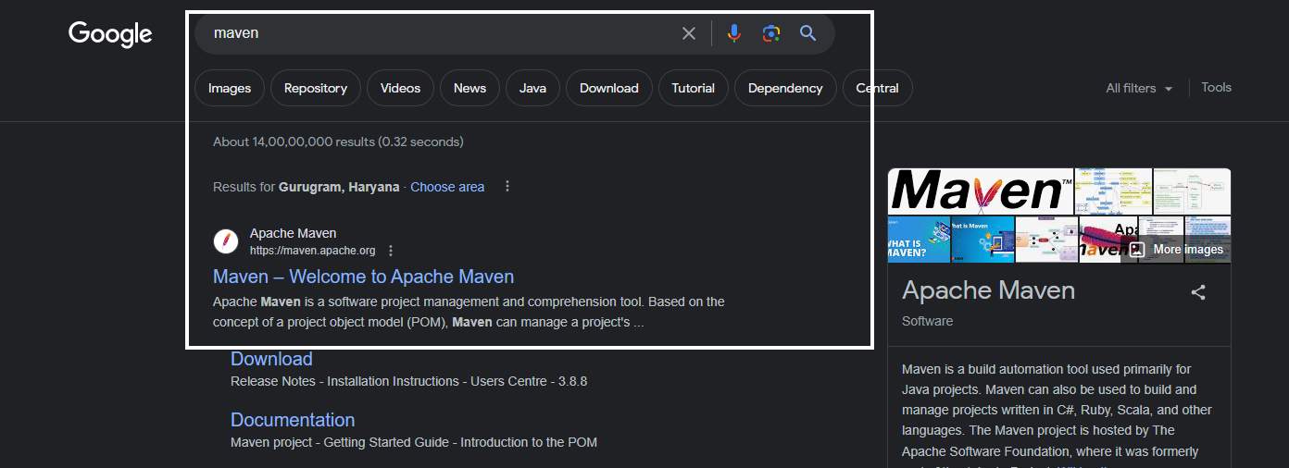

**Step 2 –** Click on this link and the zip file will be downloaded

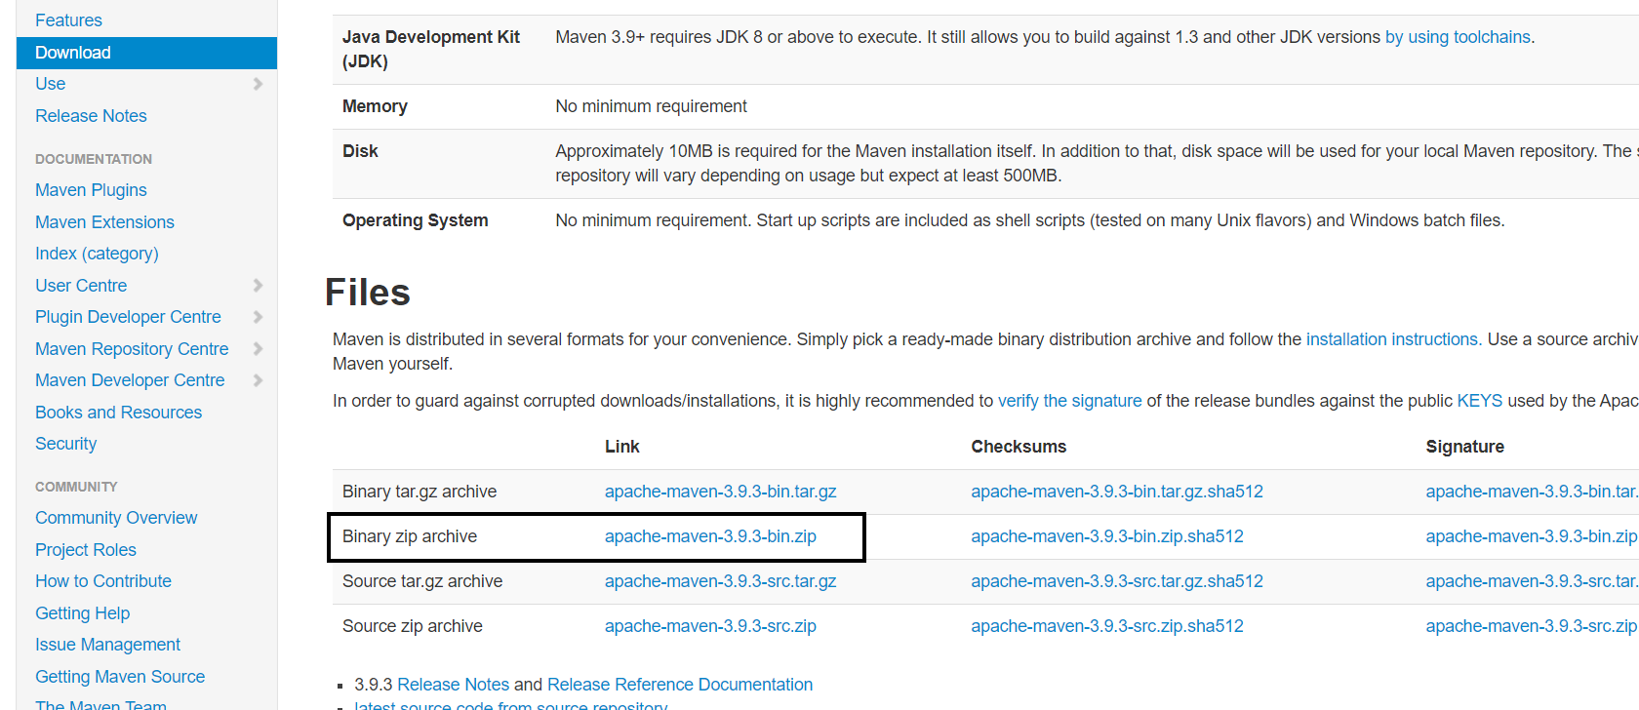

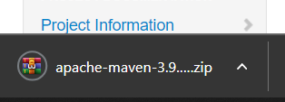

**Step 4 –** Copy the path where maven is downloaded. Go to Environment variables . Under System Variables , click on Path .

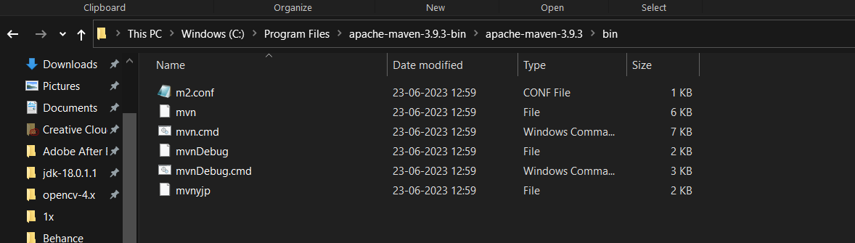

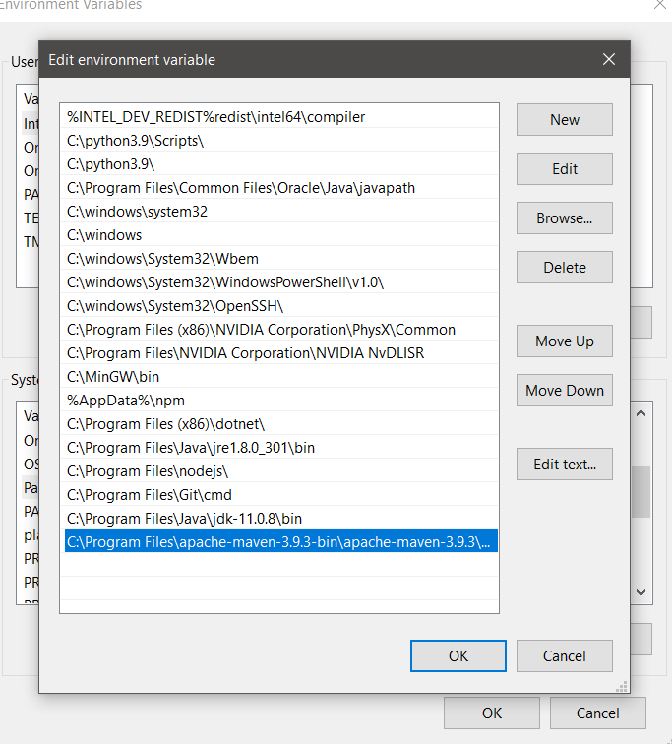

**Step 6 –** Now click on New, add the copied path and name of the variable as shown in the image below and click on ok.

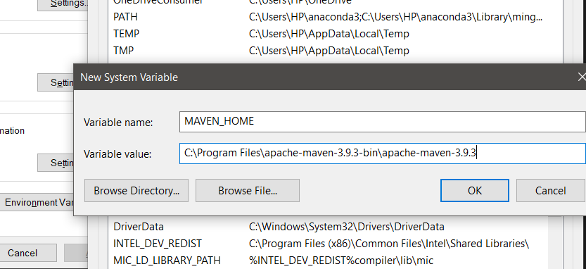

**Github(Desktop) Download and Installation Steps**

**Download and Installation Process**

**Step 1 –** Search for Github Download and click the link

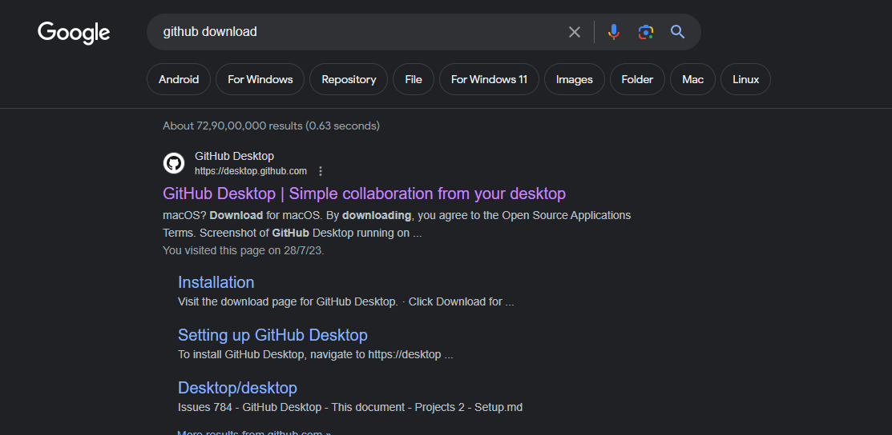

**Step 2 –** Click this Link and the Download will start

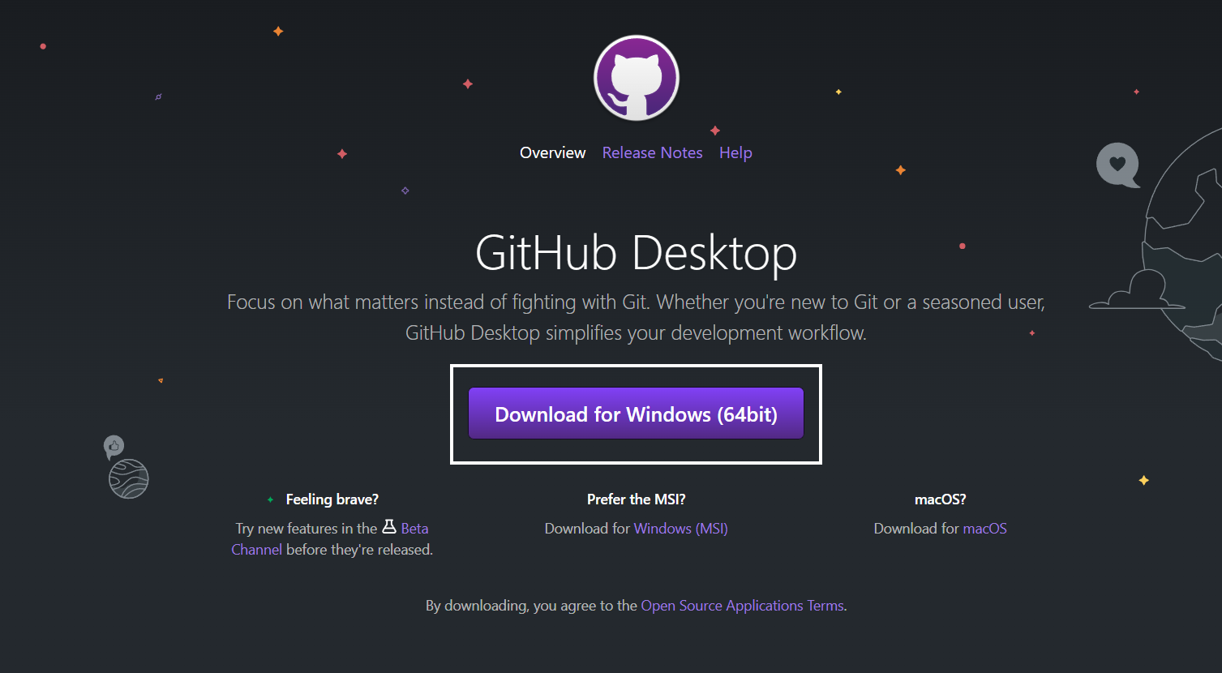

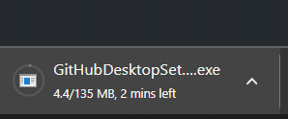

**Step 3 –** Now Sign-in or Sign-up in your Github Account

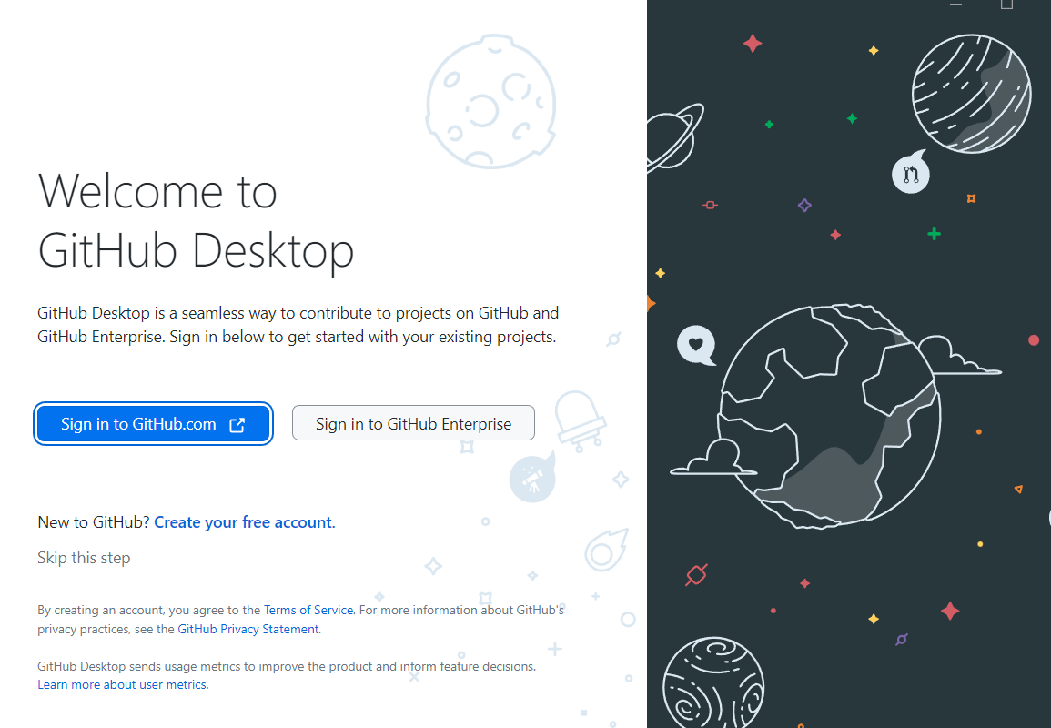

**Postman Download and Installation Steps**

**Postman Desktop Download**

**Step 1 –** Search for “Download Postman” or go to this link :

<https://www.postman.com/downloads/>

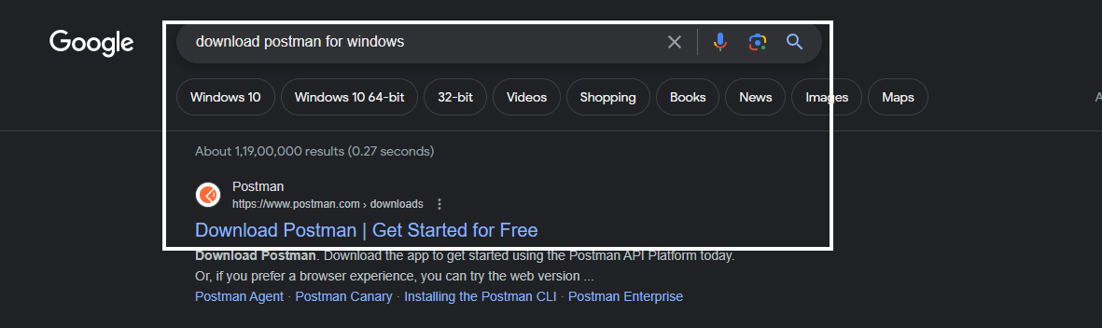

**Step 2 –** Click the Download button for windows

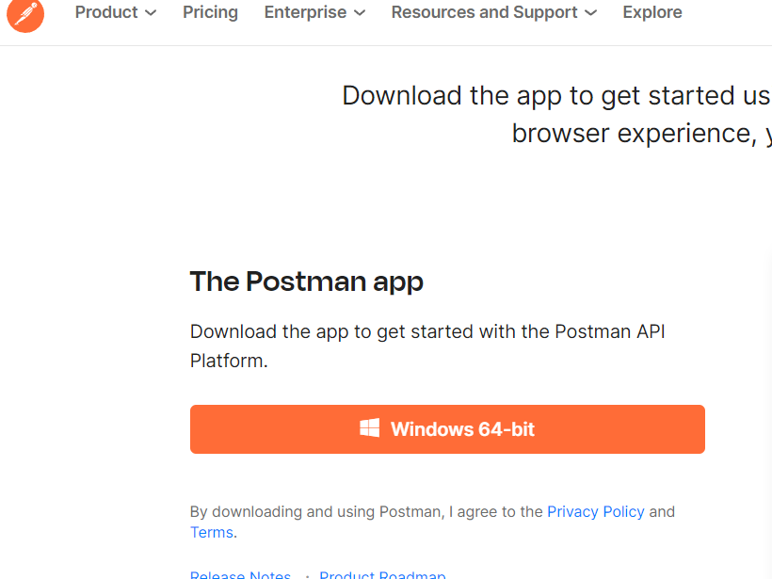

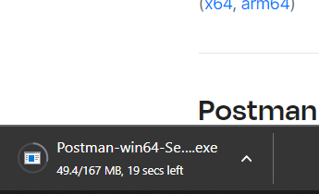

**After Installation this window will open**

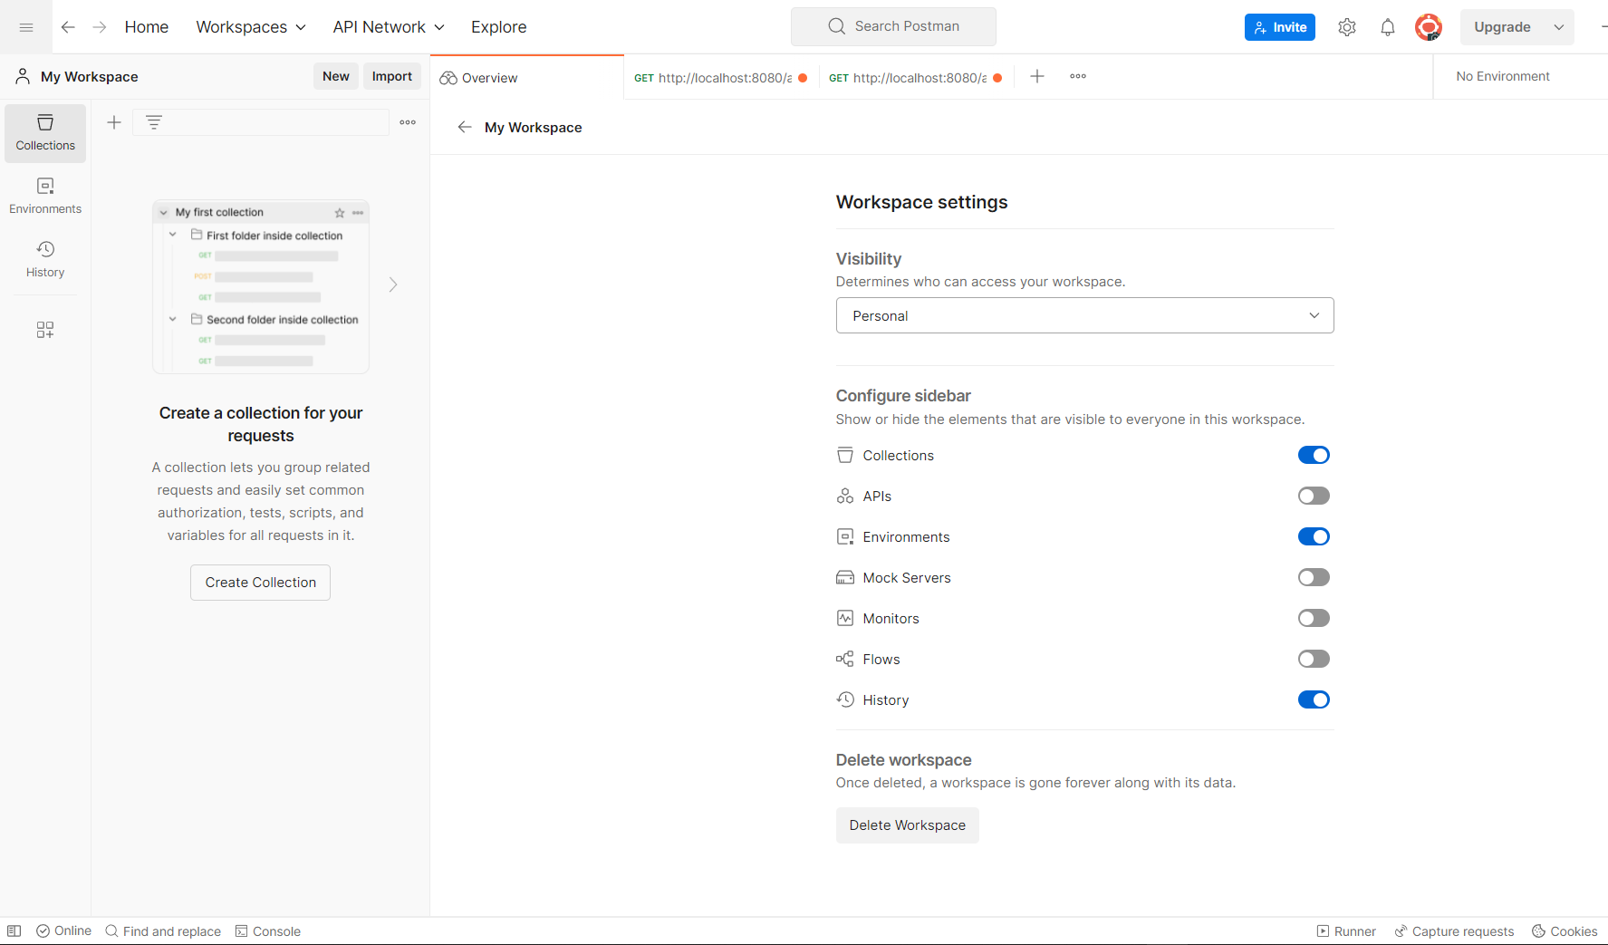

**Postman Web**

**Step 1 –**



**You can also use the web version of postman.** Click on this link : <https://identity.getpostman.com/login> . Login or sign up and the workspace will open for web Postman

